IT 125-41194

Alex Arnold

3-3-25

Lab 6-2-4

Part 1

B – show configuration

C - configure trunk ports

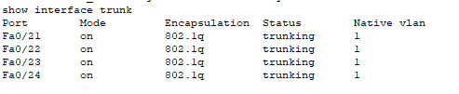

S3

S2

S1

Part 2

Step 1 C - channel-group 1 mode desirable

S1

S3

Step 1 D - Configure the logical interface



S1

S3  
 Step 2 A – verify configuration

S1

S3

Part 3

Step 2 – Verify Port Channel 2 status.

S1

Step 2

Part 4

Step 1 configure channel 3

Step 2 - verify channel 3 status

